 | 1A
Team | Exercise | Amendment *
Date of receipt **
Result of evaluation **

Technical University of Lodz
Department of Microelectronics and Computer Science
Laboratory report
for
Power Devices and Systems
Exercise 1A
Thyristors

version 5.7

Dates of laboratory sessions
Team composition during exercise realisation

* Amendment number; leave blank for a first version.
** Filled in by the teacher.
All the general comments provided in the report template for Exercise 2 apply to the present report, in particular those concerning tables, formulae, symbols, graphs and other figures.
In order to illustrate the expected form of result presentation, the template contains selected partial (not complete) examples of numerical results and graphs. All of these were obtained for the same values ​​of structure parameters and are consistent with each other. They serve as an illustration of the correct way of processing the results, whereas they are not numerically correct for input data appropriate for particular teams.
The points marked with an asterisk (*) are optional. Their impact on exercise assessment is defined in the Laboratory regulations. In case they are omitted, they should not be removed from the document, as this would affect the automatic point numbering. If the team wishes to make it clear that a point has been omitted, the character “x” can be inserted in place of an answer.
Comments on exercise realisation

Symbols

Carrier concentration distribution

Embed your saved graphs presenting carrier density and electric potential distribution in the conducting state along SBD and along PIN diode. They should be arranged so that plots for the same structure parameters (N_{D} and W_{I}) and three different forward current values I_{F} in ascending order. Include the initial case (N_{D,ini}, W_{I,ini(A)}), two cases for different values ​​of N_{D} and two cases for different values of W_{I}.
The results presented were obtained using the spreadsheet pin_sbd_stan_przewodzenia.ods.
Further comparative analysis of graphs may be made easier if pages containing the results are printed, as it is not possible to simultaneously display all these pages on the screen.
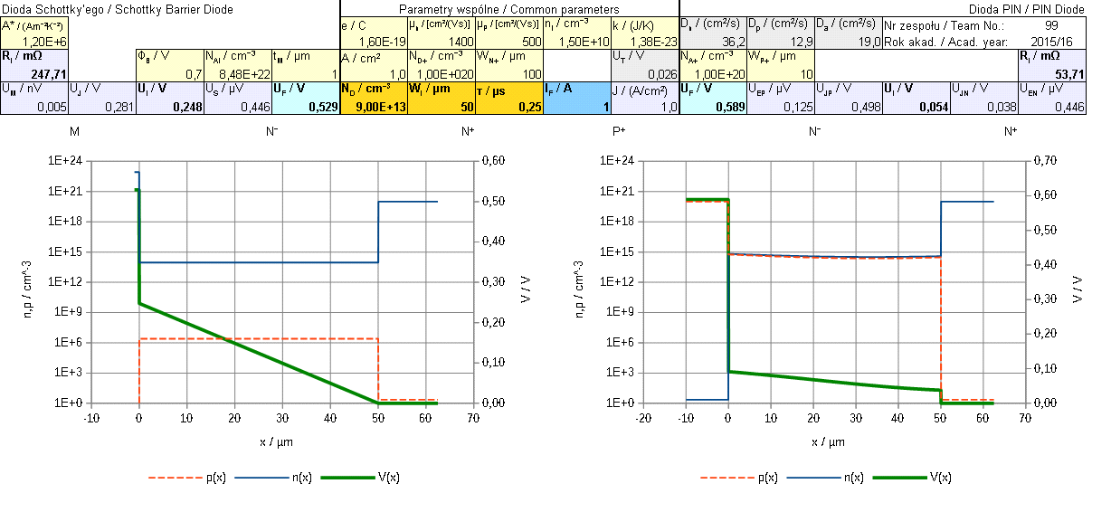
(a)
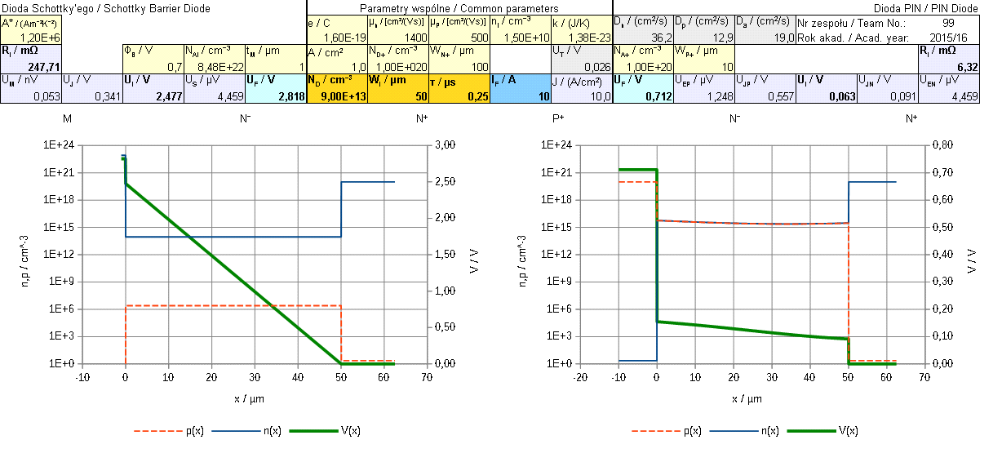
(b)
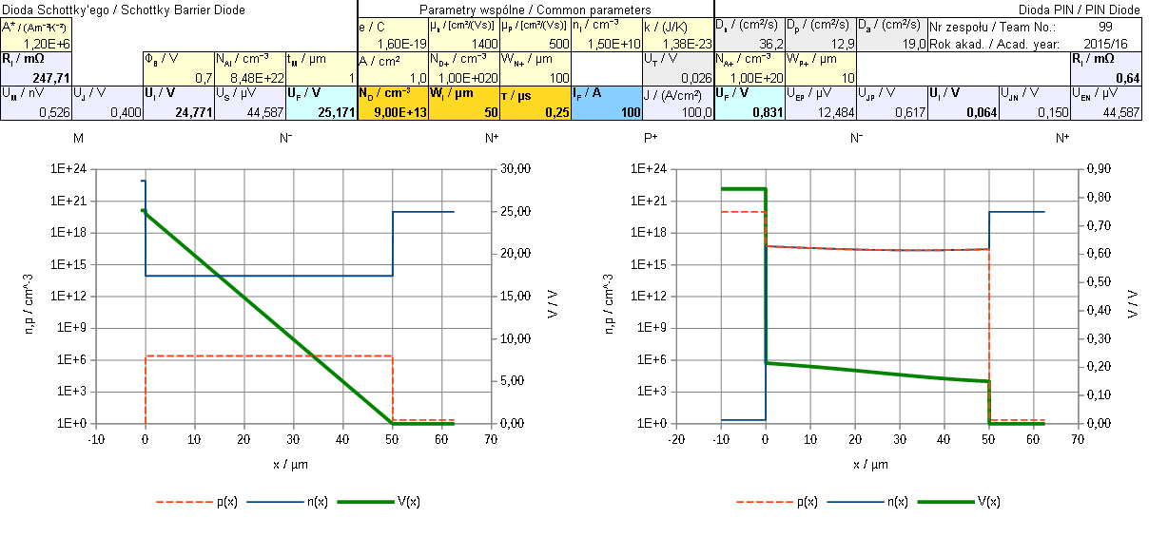
(c)
Fig. 1. Carrier density and electric potential distributions in the conducting state along SBD and PIN diode for τ = τ_{ini} =?, N_{D} = N_{D,ini} =?, W_{I} = W_{I,ini(A)} = ?, for different currents: (a) I_{F} = 1 A; (b) I_{F} = 10 A; (c) I_{F} = 100 A

(a)

(b)

(c)
Fig. 2. Carrier density and electric potential distributions in the conducting state along SBD and PIN diode for τ = τ_{ini} = ?, N_{D} = ?, W_{I} = ?, for different currents: (a) I_{F} = 1 A; (b) I_{F} = 10 A; (c) I_{F} = 100 A

(a)

(b)

(c)
Fig. 3. Carrier density and electric potential distributions in the conducting state along SBD and PIN diode for τ = τ_{ini} = ?, N_{D} = ?, W_{I} = ?, for different currents: (a) I_{F} = 1 A; (b) I_{F} = 10 A; (c) I_{F} = 100 A

(a)

(b)

(c)
Fig. 4. Carrier density and electric potential distributions in the conducting state along SBD and PIN diode for τ = τ_{ini} = ?, N_{D} = ?, W_{I} = ?, for different currents: (a) I_{F} = 1 A; (b) I_{F} = 10 A; (c) I_{F} = 100 A

(a)

(b)

(c)
Fig. 5. Carrier density and electric potential distributions in the conducting state along SBD and PIN diode for τ = τ_{ini} = ?, N_{D} = ?, W_{I} = ?, for different currents: (a) I_{F} = 1 A; (b) I_{F} = 10 A; (c) I_{F} = 100 A

In which diode are carrier concentrations in the lightly doped layer higher?

In what way, if at all, do these concentrations change with increasing forward current I_{F}? (Do not look now into their distribution along the x-axis.)

SBD:

PIN diode:

Based on Figs. 1—5, justify which diode exhibits the presence of excess carriers (Manual 0, Refs. I and J).

Based on Figs. 1—5, justify in which diode the unipolar nature of current conduction is manifested, and in which, the bipolar one (Refs. A and D; Manual 0, Ref. H).

Remind which group of carriers (equilibrium or excess ones) dominates in the case of unipolar conduction, and which, in the bipolar one (Ref. A; Manual 0, Refs. I and J). On what parameters or physical quantities, and in what way, does the concentration of these carriers depend (describe or quote a formula)?

Unipolar conduction:

Bipolar conduction:

Explain your observations from point 1.3 referring to your answers given in points 1.4—1.6.

Electric potential distribution in the lightly doped layer

In which diode is the voltage drop across the lightly doped layer at the same current density lower (formulate a general rule)? Make use of U_{I} values displayed in Figs. 1—5; check that the same drop is shown by the electric potential distribution curve between the ends of the considered layer.

For a semiconductor layer, remind (quote appropriate formulae) how the following parameters relate to each other (Ref. A; Manual 0, Ref. I):

conductivity to carrier concentration;

Unipolar conduction:

Bipolar conduction:

resistivity to conductivity;

voltage drop to resistivity (for simplicity, disregard the influence of diffusion, i.e. only consider drift).

Explain the observation from point 2.1 based on your observation of point 1.2, also making use of your answers given in point 2.2.

* Explain the non-linearity of the electric potential distribution curve V(x) (manifesting particularly clearly for large widths W_{I} and small currents I_{F}). Refer to the carrier density distribution curves n(x) and p(x). Make use of your answer given in point 2.3.

In what way, if at all, do the voltage drop U_{I} and the equivalent resistance of the lightly doped layer R_{I} = U_{I} / I_{F} (Figs. 1—5) vary with an increase in the conduction current?

SBD:

PIN diode:

Based on your answer given in point 2.5, justify, in which diode conductivity modulation of the lightly doped layer is observed (Ref. A).

Link the above conclusion to the observations made in point 1.3. Take advantage of your reasoning presented in point 2.3.

Components of the total voltage drop

Compare the U_{J} voltage across the MN junction in the SBD with the U_{JP} voltage across the PN junction in the PIN diode (Figs. 1—5). How does each of them change with increasing current? Does this cause their mutual relation change?

Which element of the structure contributes more to the total voltage drop across the diode (formulate a general rule): the lightly doped layer or the MN/PN junction? Does this depend on the value of the current? Make use of the electric potential distribution curves v(x) (Figs. 1—5) at the appropriate locations along the analysed semiconductor structures. Note that in some cases of specific (particularly large or small) values of the technological parameters N_{D} and W_{I}, these contributions may be different.

SBD:

PIN diode:

* Does any other element of the considered semiconductor structures (Refs. A and E) have a significant contribution to the total voltage drop?

Static characteristics against current

In a table, collect numerical results written down or calculated for the conducting state, for a constant carrier lifetime τ = τ_{ini}.
The results presented were obtained using the spreadsheet pin_sbd_stan_przewodzenia.ods.
Table. 1. Electrical parameters of diodes in the conducting state for different values ​​of technological parameters and current, for the initial minority carrier lifetime of τ_{ini} = ?
N_{D} / cm⁻³ | W_{I} / µm | I_{F} / A | U_{F} / V |  | R_{on} / mΩ |  | P_{on} / W
N_{D} / cm⁻³ | W_{I} / µm | I_{F} / A | SBD | PIN | SBD | PIN | SBD | PIN
1.00×10¹⁴ | 100 | 1 | 0.73 | 0.63 |  |  | 0.73 | 0.63
1.00×10¹⁴ | 100 | 10 | 4.80 | 0.75 |  |  | 48.00 | 7.48
1.00×10¹⁴ | 100 | 100 | 44.99 | 0.87 |  |  | 4498.77 | 86.71
1.00×10¹⁵ | 100 | 1 |  |  |  |  | 0.33 | 0.62
1.00×10¹⁵ | 100 | 10 |  |  |  |  | 7.87 | 7.45
1.00×10¹⁵ | 100 | 100 |  |  |  |  | 485.92 | 86.69
Formulae used for calculations:

Embed the plots of characteristics of voltage U_{F} = f(I_{F}, N_{D}) and equivalent resistance R_{on} = f(I_{F}, N_{D}).

Fig. 6. Characteristics of voltage across the diode as a function of forward current for W_{I} = W_{I,ini(A)} = ? and various dopant concentrations in the lightly doped layer N_{D}

Fig. 7. Characteristics of equivalent resistance of the diode as a function of forward current for W_{I} = W_{I,ini(A)} = ? and various dopant concentrations in the lightly doped layer N_{D}

Based on the exponents a of the regression functions y = bxª shown in the graph, determine the approximate nature of the relation of the voltage across the device to the forward current for either diode (increasing / decreasing / constant; is it close to any function, e.g. linear, inversely proportional, etc.?)

SBD:

PIN diode:

What is the nature of the relation of the equivalent resistance of the device to the forward current for either diode?

SBD:

PIN diode:

Explain the above observations referring to your answer given in point 2.6.

Based on your observations from point 4.4, explain the origin of the nature of the voltage to forward current relation (point 4.3). Refer to the relationship linking the voltage U_{F} to the equivalent resistance R_{on} and to the independent variable, i.e. the current I_{F}.

Embed the plot of the characteristic of power dissipation P_{on} = f(I_{F}, N_{D}).

Fig. 8. Characteristic of power dissipation in the diode as a function of forward current for W_{I} = W_{I,ini(A)} = ? and various dopant concentrations in the lightly doped layer N_{D}

What is the nature of the relation of the dissipated power to the forward current for either diode?

SBD:

PIN diode:

Explain the origin of the power to forward current relation based on your observations concerning the voltage across the diode (point 4.3). Refer to the relationship linking the power P_{on} to the voltage U_{F} and to the independent variable, i.e. the current I_{F}.

Effect of structure parameters

Based on Fig. 6, compare both diodes in terms of direction (increasing / decreasing / constant function) and strength (i.e. weak, proportional, etc.) of the impact of dopant concentration in the lightly doped layer N_{D} on the equivalent resistance of the diode R_{on} and on the voltage drop across it U_{F}.

SBD:

PIN diode:

Explain the differences observed taking advantage of your answers given in point 1.6 and your reasoning presented in point 2.3.

Embed the plots of characteristics of voltage U_{F} = f(I_{F}, W_{I}) and equivalent resistance R_{on} = f(I_{F}, W_{I}).

Fig. 9. Characteristics of voltage across the diode as a function of forward current for N_{D} = N_{D,ini} = ? and various lightly doped layer widths W_{I}

Fig. 10. Characteristics of equivalent resistance of the diode as a function of forward current for N_{D} = N_{D,ini} = ? and various lightly doped layer widths W_{I}

Based on Fig. 9, compare both diodes in terms of the direction of the impact of the lightly doped layer width W_{I} on the equivalent resistance of the diode R_{on} and on the voltage drop across it U_{F}.

SBD:

PIN diode:

Explain your observations concerning the equivalent resistance. Quote the theoretical relationship linking the resistance of a conductor to its resistivity and its longitudinal dimension. Note that the parameter R_{on} refers to the entire device, whereas W_{I}, only to one element of its structure; in this context, refer to your exhaustive answer given in point 3.2.

Explain your observations concerning the voltage referring to those concerning the equivalent resistance.

* Analysing again Figs. 1—5 (selected as appropriate), determine the nature (e.g. proportional, stronger, weaker, negligibly weak) of the relation of the voltage drop across the lightly doped layer U_{I} to its width W_{I} for either diode.

SBD:

PIN diode:

* Explain the above observations:

does only the longitudinal dimension change in the formula quoted in point 5.5, or some other parameter does as well?

what does the change of the latter parameter result from? (refer to the plots of Figs. 1—5);

what is the nature of this change and how does it affect the voltage?

are your observations consistent with theoretical predictions? Quote analytically derived formulae expressing the voltage drop across the lightly doped layer in a unipolar device and in a bipolar device (Refs. A and G).

Embed the plot of the characteristic of power dissipation P_{on} = f(I_{F}, W_{I}).

Fig. 11. Characteristic of power dissipation in the diode as a function of forward current for N_{D} = N_{D,ini} = ? and various lightly doped layer widths W_{I}

Based on Figs. 6—11, state which diode generally exhibits more favourable properties (name them) considering its application as a switch in power converters (Manual 0, Ref. G). For what (large / small) forward current I_{F} and for what values of the parameters N_{D} and W_{I} of the lightly doped layer, however, diodes of the second type are better?

Current capability

Embed a table containing the current capability of the analysed diodes as determined.
Example readings were made ​​under the assumption of P_{d,max} = 10 W.
Table. 2. Maximum admissible forward current of the diodes for various technological parameters assuming an admissible power dissipation P_{d,max} of ?
N_{D} / cm⁻³ | W_{I} / µm | I_{Fmax} / V
N_{D} / cm⁻³ | W_{I} / µm | SBD | PIN
1.00×10¹⁴ | 100 | 4,0 | 13
1.00×10¹⁵ | 100 | 11 | 13

Embed the plots of current capability as a function of lightly doped layer dopant concentration and width.

Fig. 12. The relation of maximum admissible diode current to dopant concentration in the lightly doped layer, assuming an admissible power dissipation P_{d,max} of ?

Fig. 13. The relation of maximum admissible diode current to the lightly doped layer width, assuming an admissible power dissipation P_{d,max} of ?

Compare the two types of diodes in respect of the nature (strength and direction) of the relation of the current capability I_{Fmax} to the technological parameters of the lightly doped layer:

the dopant concentration N_{D};

the width W_{I}.

Based on Figs. 12—13, state which diode generally enables achieving a higher current capability. For what (large / small) values of lightly doped layer parameters N_{D} and W_{I}, this capability will, however, be higher for diodes of the other type?

Effect of minority carrier lifetime (PIN diode)

Embed your saved graphs of electric potential distribution for two values of minority carrier lifetime in the lightly doped layer τ (for τ and for τ_{ini}/3). Both graphs must be found on the same page.

(a)

(b)
Fig. 14. Carrier density and electric potential distributions in the conductive state along the PIN diode (the plots for the SBD are insignificant) for N_{D} = N_{D,ini} = ?, W_{I} = W_{I,ini(A)} = ?, I_{F} = 10 A and different minority carrier lifetimes: (a) τ = τ_{ini} = ?; (b) τ = τ_{ini}/3 = ?

From the figures, for either value of τ, read out and enter in the table the following values displayed in the spreadsheet:

voltage drop across the lightly doped layer of the PIN diode U_{I};

* PN junction voltage U_{JP} and the total voltage drop U_{F} across the PIN diode.
Table 3. Voltage drop across the PIN diode for different minority carrier lifetimes (N_{D} = N_{D,ini} = ?, W_{I} = W_{I,ini(A)} = ?, I_{F} = 10 A)
τ / µs | U_{I} / V | U_{JP}/ V | U_{F} / V

How does shortening the lifetime τ affect the voltage drop across the lightly doped layer?

Based on the graphs, state what, if at all, is the effect of the lifetime τ on the carrier concentration in the lightly doped layer. Take into account both values globally and the shape of their distribution curve along the layer.

Explain your observation from point 7.3 based on your answer given in point 7.4. Take advantage of your reasoning presented in point 2.3 again.

* Based on Table 3, determine the effect of the minority carrier lifetime on the voltage across the PN junction.

* Explain the above observation by quoting the appropriate formula linking voltage across the junction to carrier concentration (Manual 0, Ref. K) and by analysing Fig. 14.

* Based on Table 3, determine the effect of the minority carrier lifetime on the total voltage drop across the PIN diode. Explain this relationship based on your answers given in points 7.3 and 7.6 as well as 3.2 and 3.3.

Considering the application of diodes as semiconductor switches, is short or long minority carrier lifetime more favourable from the point of view of static properties (voltage drop, power dissipation)?

